**Creating a Captivate Assessment and Demo**

1. Open Captivate so that it starts to load (it takes a while so move onto the next stage whilst waiting).
2. Load the software screens that you want to record for a demo / assessment.
3. 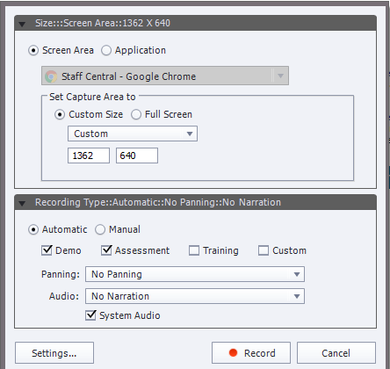Once Captivate has loaded, choose **Software Simulation** and click on **Create.**
4. A dialogue / options box will appear.
   1. Choose the screen that you want to record (It most cases you can choose application’ and then choose the region). *If you have a website and you don’t want to see the web address on the video either choose ‘screen area’ and ‘full screen’ and BEFORE you record change the browser window to full screen (F11) OR choose screen area and choose ‘custom size’ and you will see a red box around the browser window. You can resize this red box to just record part of the browser screen).*
   2. Keep the recording type as **Automatic.** Select the options that you need (probably Demo and Assessment).

**Tips:**

If you can record a demo in one take and you just want to show the mouse clicks and audio, use Camtasia Relay to create the demo (it will be quicker!)

If you want to be able to edit the demo, use the demo mode in Captivate.

If you want the assessment just to be a series of clicks, record this separate to the demo. For the assessment recording, simply go through the process (no audio or explanation) and do the mouse clicks / typing. When you come to edit the final assessment you won’t have so many elements to edit.

* + - **Demo**: Records what you do on the screen and adds highlight boxes where you click and some minimal instruction boxes (such as ‘select’).
    - **Assessment**: Adds click boxes in places where you click when initially recording. These click boxes can be edited (made larger) as part of the final assessment. Users need to click on those places to move on.
    - **Training**: A bit a mixture of the above. Records the demo and adds click boxes where the user needs to click. When watching the video, the user needs to click in the right place before the rest of the demo continues.
    - **Custom**: Allows you to choose which bits of the above to use (manually create the interactions).
  1. Choose ‘No Panning’ (Panning moves the whole page around as you record (not recommended).
  2. If you want to narrate as you go, choose the narration option (you can edit or replace the narration after recording or you can add narration in the editing stage).
  3. System Audio will records the alert noises from the software (remove if you don’t want to do this). *If you have an email alert on your PC and you choose to record system audio it will pick this up so turn off your emails!)*

1. Click on **Record.** You will get a countdown of 3,2,1 to start recording. The software will now record everything that you do on the screen (and your voice if you have chosen audio). When you want to stop press the **End** key on your keyboard.
2. Your video and slides will be saved (this can take a while).
3. Once the Captivate window opens again you will see a tab for each recording type that you have chosen (eg: one tab for demo, one for assessment). Select the one that you want to edit (they now become independent).

**Setting up the software for editing**

1. On the left of the window you will see each of the slides you have created as part of the video (this is called the **Filmstrip)**. Items with a speaker indicate some audio on the slide, those with a video icon indicate that you have some movement on the slide. As you select a slide on the left it will appear in the middle.
2. Click on **Properties** on the top right hand side. This will appear on the right hand side. This is where you will edit the look and use of the boxes or interactions on the video.
3. To make it easier to edit and use add the **Timeline** so that you can see all the items on the slide. To do this, click on **Window** and choose **Timeline**. This appears at the bottom of the screen. Each line on the timeline is a feature on the slide (eg: audio line, caption box, click box etc). When you click on one of these (on the timeline or the slide) the relevant options will appear in the properties box on the right hand side.
4. You will probably find that the slide / video is too large for the middle of the screen now. Towards the end of the menu options there is a zoom option (highlighted below). Reduce the zoom to around 50 and then increase to make it is large as you can on your screen so that you can see the full screen.

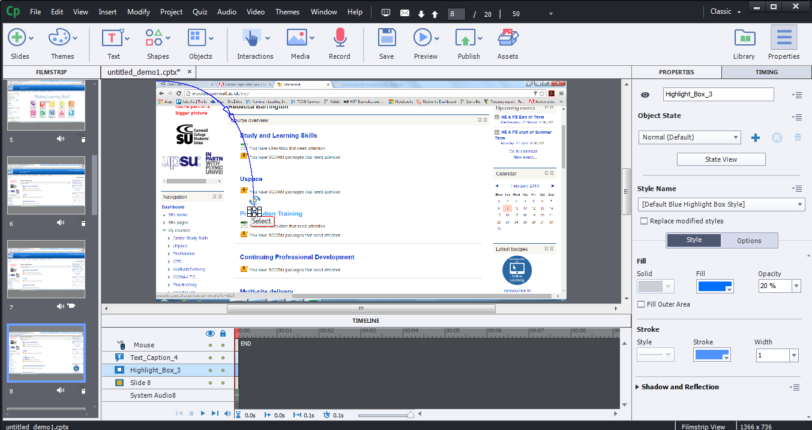

**Editing a Demo**

1. Click on the first slide in your list. You can watch the slide by clicking on **Preview** on the top menu bar (choose this slide). You can watch what is happening on the timeline at the bottom of the screen.
2. You can make the slide play time longer or shorter by using the **slide #** line on the timeline and drag the right hand edge left (to make it shorter) or right (to make it longer).
3. If you want to change the text that is showing on the page (eg: change ‘Select’ to ‘Click here’) double click on the text and re-type the information you need. You can also resize the box. You can also change the colour of the text or box using the properties box on the right hand side (scroll up and down to choose the options).
4. If you want to add text or images to the page (such as instructions, annotations, to highlight a part of the page), click on **text** or **shapes** on the top menu bar. Choose your options and draw them onto your slide. You can change colours, fonts etc using the properties box on the right of the page.
5. If there is anything on the slide that you don’t want, click on it and press the delete key.
6. If there is already audio on the slide you will see a narration line on the bottom timeline. Double click on it to edit it. You will see the audio marks. You can listen, highlight the bits you want to remove and click on the scissors icon to delete it. If you want to add some audio, click where you want to add it and and click on record. Stop when you are finished and edit as before. To replace the audio, delete it all and click on record to add some more.
7. If there is no audio and you want to add some, click on **record** on the top menu bar and record the audio to add to the slide.
8. Repeat the above for each slide.

**Editing an Assessment**

1. Everything is the same as above plus:
2. You will probably need to make click boxes larger (as part of the recording, the click boxes only appear where you clicked but the actual clickable space is probably larger. To make it larger, click on it once on the main page and you can then use the corners to resize it.
3. After you have clicked on the edit box take a look at the ‘actions’ options in the **Properties** box on the right hand side. By default, the action is to pause the video and only move to next slide if the user clicks in the right place. You will probably leave it as this. Note that, in the **Display** options that only ‘failure’ is ticked which means some text will only appear if the user clicks on the wrong place (see action 24 below). You can add a ‘well done’ type box by adding a tick in the ‘success’ box.

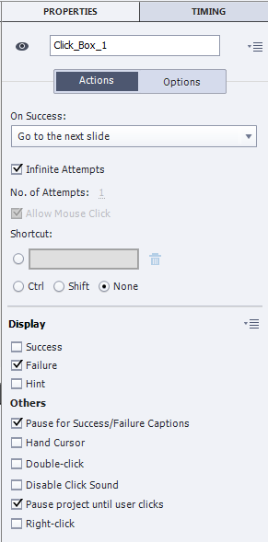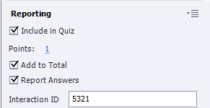

1. Another thing to note on the properties box when you click on the click box are the ‘reporting’ options. When we create an assessment we can make it so that users get a point for clicking in the right place. This information can be sent to Moodle so that we know what scores users get in their assessment. Make sure that the boxes are ticked as shown on the right hand side.
2. On your slide you will see a ‘try again’ text box that has been created automatically. You will probably want to change this so that something more useful appears when a user clicks in the wrong place. Click on it to edit it in the same way as other text boxes (change the text by clicking and typing and change the look by using the **properties** box).
3. If you want to add a new interaction, there are a range in the **interactions** menu on the top (but if you have done a simple recording as explained in the black tips box above you shouldn’t need to do this.
4. Repeat these actions for each slide.

**Saving, testing and publishing**

1. To save (which you should do often!) click on file / save as and save on your data area in the usual way. After this, just click on the save icon.
2. The watch the slides, you click on **Preview** on the top menu bar. View in browser tends to work best.
3. To publish a **Demo** click on **Publish** on the top menu bar and choose **Publish to computer**.
   1. 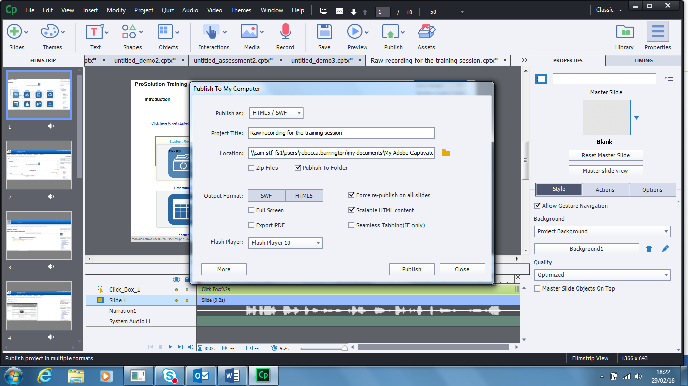Choose **HTML5 / SWF**
   2. Give it a name and choose a relevant place to save (if you don’t want the default)
   3. Select HTML5 box to make sure it records as HTML5 (choose the options shown on the right).
   4. Click on publish.
4. To publish an assessment we need to change some settings first. Go to file and choose **publish settings.**
   1. Under the quiz heading click on **reporting.**
   2. At the top of these options there is a tick box next to **Quiz**. Click on it to add a tick.
   3. 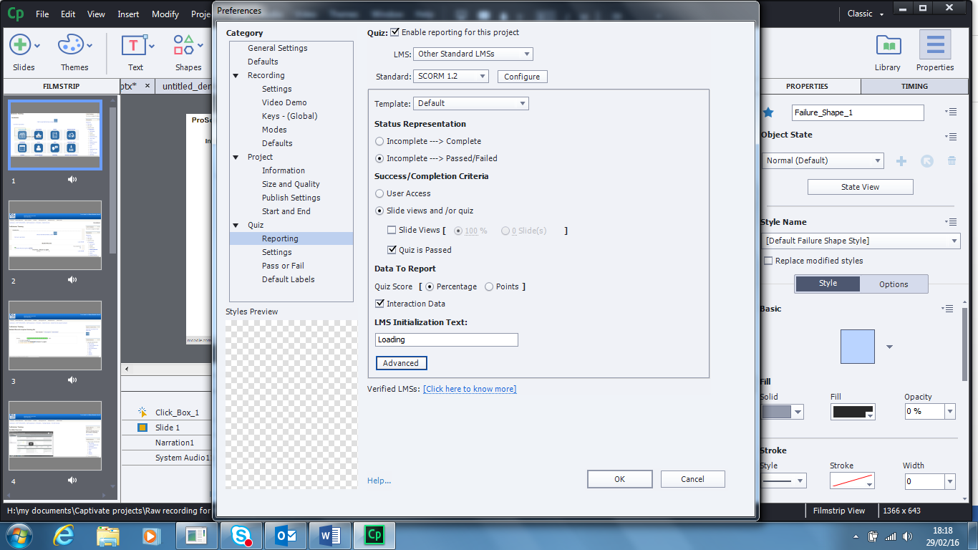Choose the options as shown here.
   4. Click on **Pass or Fail** change the pass rate to 100%.
   5. Click on **OK.**
   6. Next, click on **Publish** and choose **publish to computer.**
   7. 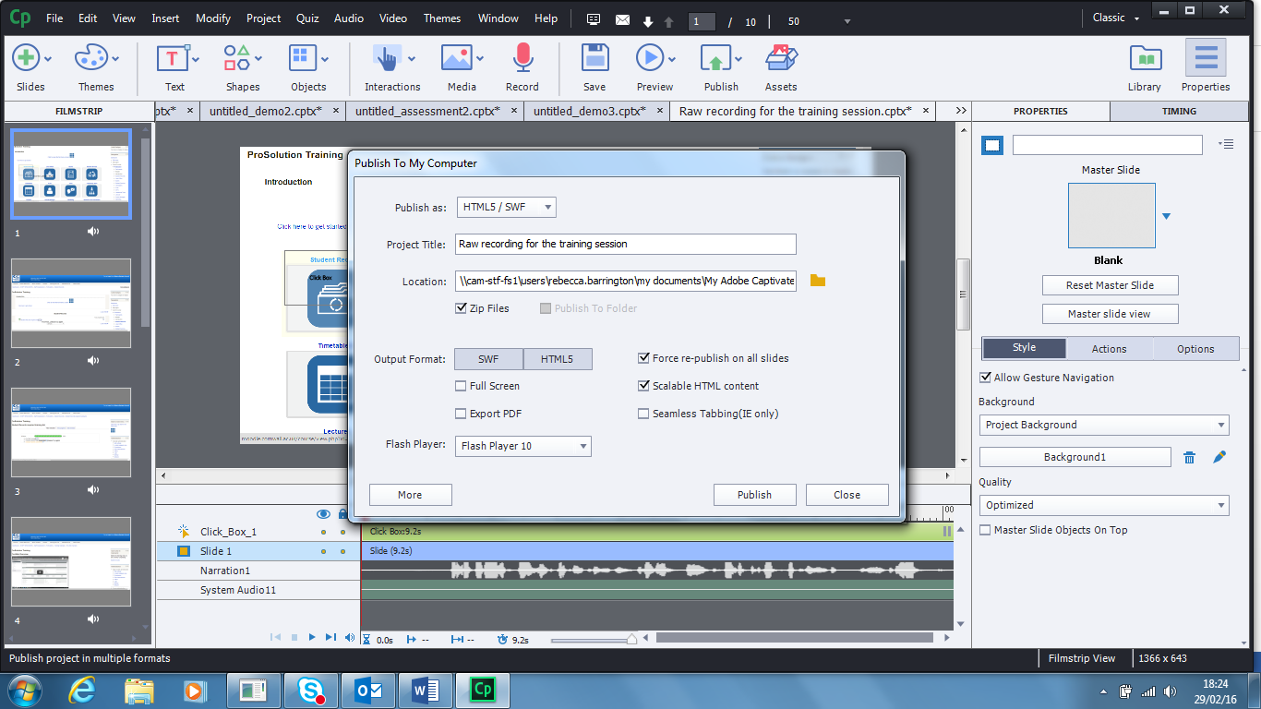Choose  **HTML5 / SWF** and make sure that **Zip files** has a tick next to it. Select the **HTML5 button**.
   8. Click on **Publish.**